Homework  
Danna Soquiat

Answer the questions by SQL.

1. List all the employees whose salaries are more than 3000.





1. List all the employees whose names begin with “S”.  
     
   
2. List the employees whose name is “SMITH”, “ALLEN” or “FORD”.  
     
   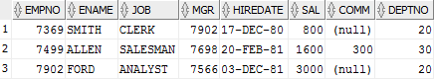
3. List all the employees whose department is “SALES”.  
   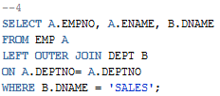  
   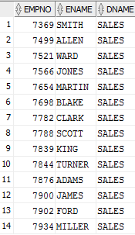
4. To get the value of average, biggest, smallest and total of each department, and order by department number.

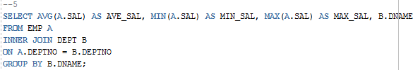

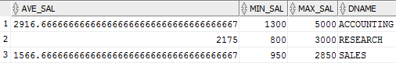

1. To get the total number of employees, whose salary is more than 3000 for each department.

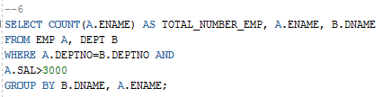



1. TO get the number of the average salary for each department, according to the department name in ascending order

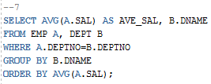  
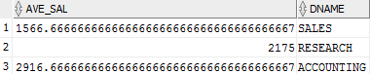

1. List the statistics of employees who have the same salary in each department, list their department number, salary, and number of employees.

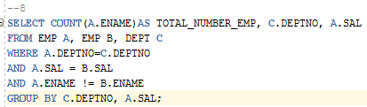  


1. List the number of employees with more than 2 employees in the same department, showing the name of the Department, the name of the area, and the number of the employees in the same department

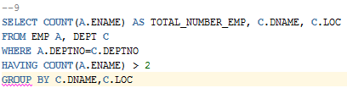

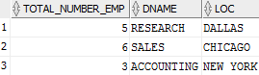

1. List the name and salary of employees whose salaries is higher than the average salary of the entire firm

